WEEKLY ACTIVITIES – Monday the 26th Of April to Sunday the 2nd of May 2021

DAY |  | PLACE | TIME | ACTIVITY
MONDAY  26th of April |  | All Floors  All Floors | 10:30am- 12.15pm  2.15-5pm | Seated Yoga With Natalia  Painting Spring Pictures With Natalia
TUESDAY  27th of April | 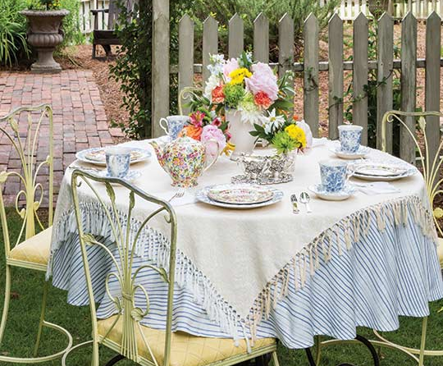 | All Floors  Individual Rooms  Garden | 10:30am- 12.15pm  10.30am-12.15pm  2.15-5pm | Seated Exercise With Jordanne  Pamper Morning With Natalia  Garden Tea Party With Natalia and Jordanne
WEDNESDAY  28th of April | 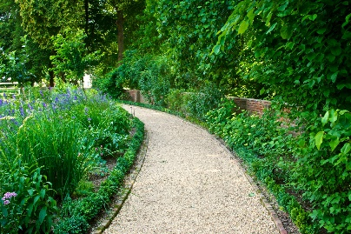 | Garden  Garden/On Floors | 10:30am-12.15pm  2.15-5pm | Walking in the Garden & a Tea Break With Natalia  Golf Putting With Natalia (Weather Dependant)
THURSDAY  29th of April |  | Individual Rooms  All Floors  Floor 1  Floor 2  Garden | 10:30am- 12.15pm  10.30am-12.30pm  10.30am-12.15pm  2.15pm  3.30pm  2.15-5pm | Manicures and Hand Massages With Jordanne  Seated Zumba Class With Natalia  Seated Exercise With Jordan  Trip Down Memory Lane Quiz With Jordanne  Sing Along in the Garden with Snacks and Lemonade With Natalia and Jordan
FRIDAY  30th of April | 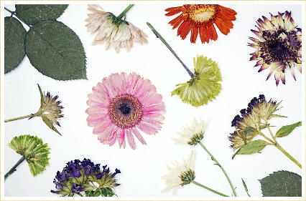  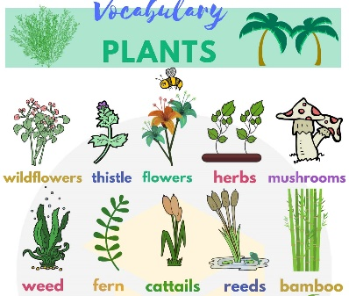 | All Floors  Ground Floor  First Floor  Second Floor  Third Floor  Individual Rooms/Small Groups | 10.30am- 12.15pm  2.15pm  2.45pm  3.30pm  4.15pm  2.15-5pm | “Can You Name These Plants?” With Jordanne  Bingo with Jordanne  Pressing Flowers With Jordan
SATURDAY  1st of May |  | Small Groups  Small Groups | 10:30am- 12.15pm  2.15-5pm | Seated Exercise With Jordan  Time Travelling Afternoon Tea With Jordan
SUNDAY  2nd of May |  | All Floors  All Floors | 10:30 am- 12.15pm  2.15-5pm | Mobile Library for World Book Day With Jordan  Movie Afternoon and Snacks With Jordan

