WEEKLY ACTIVITIES – Monday 5th of April- Sunday the 11th of April 2021
DAY |  | PLACE | TIME | ACTIVITY
MONDAY  5th of April | 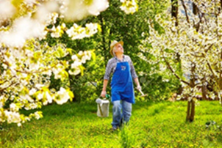 | Everyone Welcome  Individually/ Small Groups  Individually  All Lounges | 10.30am  From 10.30am  From 2.15pm  From 2.15pm | Spending time in the Garden With Jordanne  Seated Exercises With Jordan  Smell Odour Lottery With Jordanne  Easter Parade (Judy Garland) With Hot Cross Buns- With Jordan
TUESDAY  6th of April |  | Individually/ Small Groups  Small Groups | From 10.30am  From 2.15pm | Seated Yoga Class with Natalia  Cocktails & Crooners With Natalia and Jordan
WEDNESDAY  7th of April | 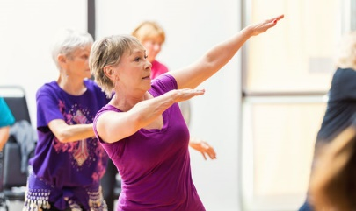  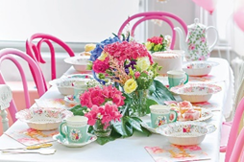 | Individually & Small Groups  Everyone Welcome  Individually & Small Groups  Small Groups  Individually & Small Groups  1st Floor  2nd Floor | From 10.30am  From 10.30am  From 10.30am  From 2.15pm  From 2.15pm  2.15pm  3.15pm | Seated Zumba Class with Natalia  Walking in the Garden With Jordan  Seated Exercises With Jordanne  Time Travelling Tea Party With Natalia  Pebble Art With Jordan  The Quiz With a Twist With Jordanne
THURSDAY  8th of April |  | Individually & Small Groups  Individually & Small Groups  Individually  Garden (Weather Dependant) | From 10.30am  From 10.30am  From 2.15pm  From 2.15pm | Meditation & Relaxation Exercises with Jordanne  Seated Exercises With Jordan  Manicures & Hand Massages With Jordanne  Planting Bulbs With Jordan
FRIDAY  9th of April |  | Individually  Ground Floor  1st Floor  2nd Floor  3rd Floor | From  10.30am  2.15pm  2.45pm  3.30pm  4.15pm | Question of the Week- “What is your All Time favourite meal?!”  Eyes Down For Bingo With Jordanne
SATURDAY  10th of April | 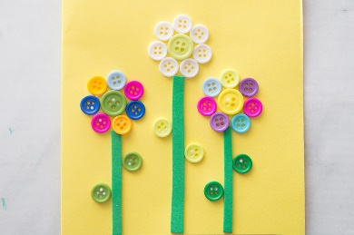 | Individually & Small groups  All Floors | From 10.30am  From  2.15pm | News of the Week With Natalia  Button Art With Natalia
SUNDAY  11th of April | 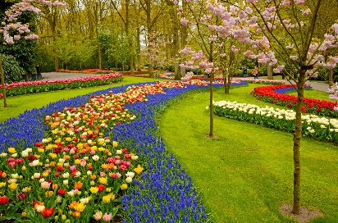 | All Floors  In the Garden | From 11am  From 2.15pm | Church Services in the Lounges With Natalia  Spending Time in the Garden (Weather Dependant) With Snacks & Lemonade With Natalia

