WEEKLY ACTIVITIES – Revised each week by the Activity Coordinators
DAY |  | PLACE | TIME | ACTIVITY
MONDAY | 400 × 225 | Groups | From 10:45am throughout the day | Bus trips –With Jordan
TUESDAY | 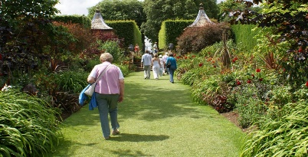  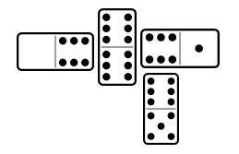 | Individually  Individual / Group  Garden  Individually  Individually/ Group | AM  AM  PM  PM  PM | Walking in the garden – With Gemma and Natalia  Seated Aerobics – With Jordan  Try a New Brew Tea Party  Dominoes - With Gemma  Arts and Crafts – With Natalia
WEDNESDAY | 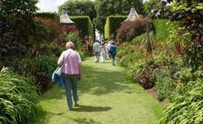 | Group  Individually  Individually & Groups  Individually  Individually | AM  AM  PM  PM  PM | Seated Zumba – With Gemma and Natalia  Walking in the Garden - With Jordan  Pub-Style Quiz – With Jordan  Manicures – With Gemma  Walking in the Garden – With Natalia
THURSDAY |  | Individually  Individually  Groups | AM  PM  PM | Walking in the Garden – With Gemma and Jordan  Individual Reminiscence – With Gemma  Mamma Mia Viewing Party and Singalong with Themed Snacks and Wine
FRIDAY |  | Groups  Groups | AM  PM | Ladies Tea Morning – With Gemma  Bingo
SATURDAY |  | Groups &  Individually  Groups and Individually | AM  PM | Walking in the Garden  Golf Putting
SUNDAY |  | Each Lounge  Groups | From 10.30am  Throughout the Day | Church Services & Prayers with Jordan  Bus Trips All Day

