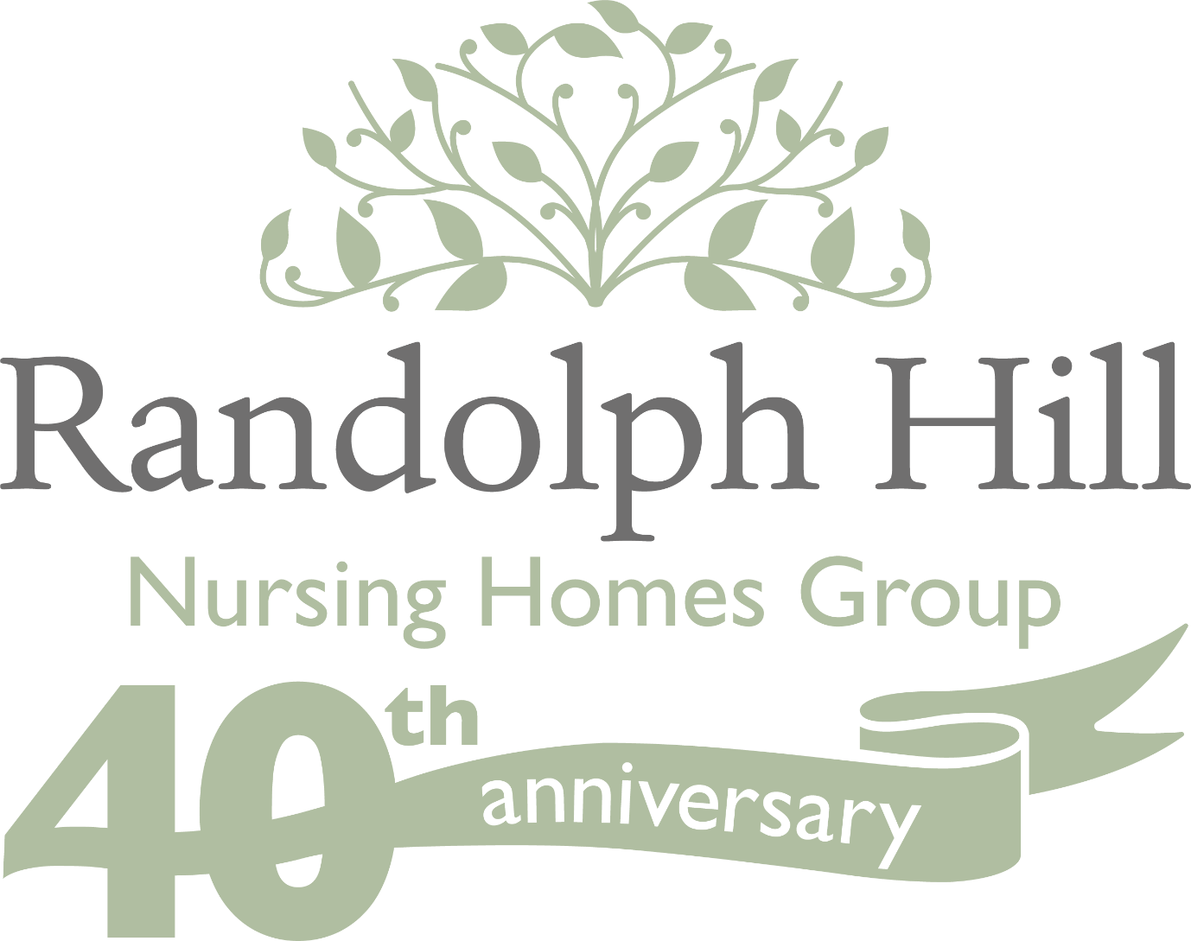

**ANNUAL DUTY OF CANDOUR REPORT**

**2024-2025**

All health and social care services in Scotland have an organisational duty of candour. This is a legal requirement which means that when certain types of incidents happen, the people affected understand what has happened, receive an apology, and the organisation learns how to improve for the future.

An important part of this duty is that we provide an annual report about the organisational duty of candour in our services. This report describes how Randolph Hill Nursing Homes Group Limited, has operated the organisational duty of candour during the time between 01 April 2024 and 31 March 2025.

**How many incidents happened to which the organisational duty of candour applies?**

In the last year, there have been no incidents to which the organisational duty of candour applied.

**Randolph Hill Nursing Homes Group**

Randolph Hill Nursing Homes Group operates seven nursing homes across Edinburgh, the Lothians and Dunblane. Six of our homes provide care and accommodation for up to 60 residents, and one for 50 residents. Our residents are older people who find it very hard to live at home. We aim to ensure our residents receive an excellent quality of care and live happy, fulfilled lives.

**Information about our policy and procedure**

The company has a Duty of Candour Policy and guidance for staff. This is always available on the company’s website. All staff receive training during their induction period about what Duty of Candour means, and the importance of being honest and open.

Senior staff receive more detailed training on the requirements of duty of candour, the company policy, and the procedure to follow.

Senior management are available on call, 24 hours a day, to give advice and support to staff where needed regarding duty of candour incidents.

We know that serious mistakes can be distressing for staff as well as people who receive care and treatment and their families. We therefore offer support for our staff if they have been affected by an organisational duty of candour incident.

**Information About Our Policies and Procedures**

Where something has happened that triggers the organisational duty of candour, our staff report this to the manager of the care home. The manager records the incident and reports this to the Care Inspectorate. When an incident has happened which meets the criteria of a duty of candour event, the manager of the service contacts the Senior Management Team who will coordinate an investigation, meeting with families and support for staff involved.

**What have we learned?**

At Randolph Hill Nursing Homes Group Limited, we recognise that unexpected or unintended incidents can occur during the provision of treatment and care. We also recognise that trust is at the heart of a caring relationship and when things go wrong and mistakes happen, then we are honest with those affected. We make sure that people affected receive an apology and that we learn how to improve for the future. We also do this for events where duty of candour legislation does not apply.

Although no incident has taken place to which duty of candour legislation applies, we will continually review all accidents and incidents to make sure we learn from events and act to learn and improve. We will regularly update policies offer support for learning and training based on up-to-date evidence and reflections of practice.

**Training and Support for staff**

All new staff learn about the organisational duty of candour at their induction. We know that serious mistakes can be distressing for staff as well as people who receive care and treatment and their families. We therefore offer support to staff if they have been affected by an organisational duty of candour incident.

**Support for relevant persons**

Where people we support and families are affected by an incident that activates the organisational duty of candour, we provide links to additional services for wellbeing support.

We hope you find this report informative. If you have any questions or would like more information about Randolph Hill Nursing Homes Group Limited, please feel free to contact us at: Randolph Hill Nursing Homes Group Limited

2nd Floor, 6 Redheughs Rigg, South Gyle, Edinburgh, EH12 9DQ Tel: 0131 523 0440 [headoffice@randolphhill.com](mailto:headoffice@randolphhill.com)